<Image Gallery Software>

Use-Case Specification: <User Registration>

Version <1.0>

Revision History

|  |  |  |  |
| --- | --- | --- | --- |
| **Date** | **Version** | **Description** | **Author** |
| <dd/mmm/yy> | <1.0> | <details> | Nguyen Kiem Hoa |
|  |  |  |  |
|  |  |  |  |
|  |  |  |  |

Table of Contents

1. User Registration 4

1.1 Brief Description 4

1.2 Actor 4

2. Flow of Events 4

2.1 Basic Flow 4

3. Special Requirements 4

4. Preconditions 4

5. Postconditions 4

6. Extension Points 4

Use-Case Specification: <User Registration>

# User Registration

## Brief Description

This use case defines the steps of registering as a user. User can easily register by providing information in field.

## Actor

User

# Flow of Events

## Basic Flow

User click the register button on login form. Then a registration form appears, users fill in that form. After that, user completes their registration by clicking the register button in the end of the form. The system will notify ‘register successful’ if username is unused and open login form else ‘invalid information’.

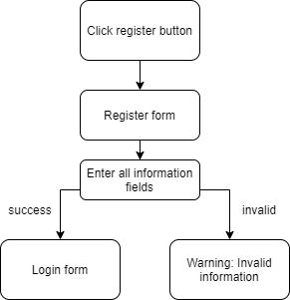

# Special Requirements

Click register button.

# Preconditions

Enter information in all fields.

# Postconditions

If username unused and valid information, system notify: register successful

Else warning: Invalid information.

# Extension Points

No extension point.